**LAN Network Basics**

**Command Prompt**

1. For windows 8 and 10: In the start menu type “cmd” to open Command Prompt
2. For windows 7 and XP: Start->Run->cmd

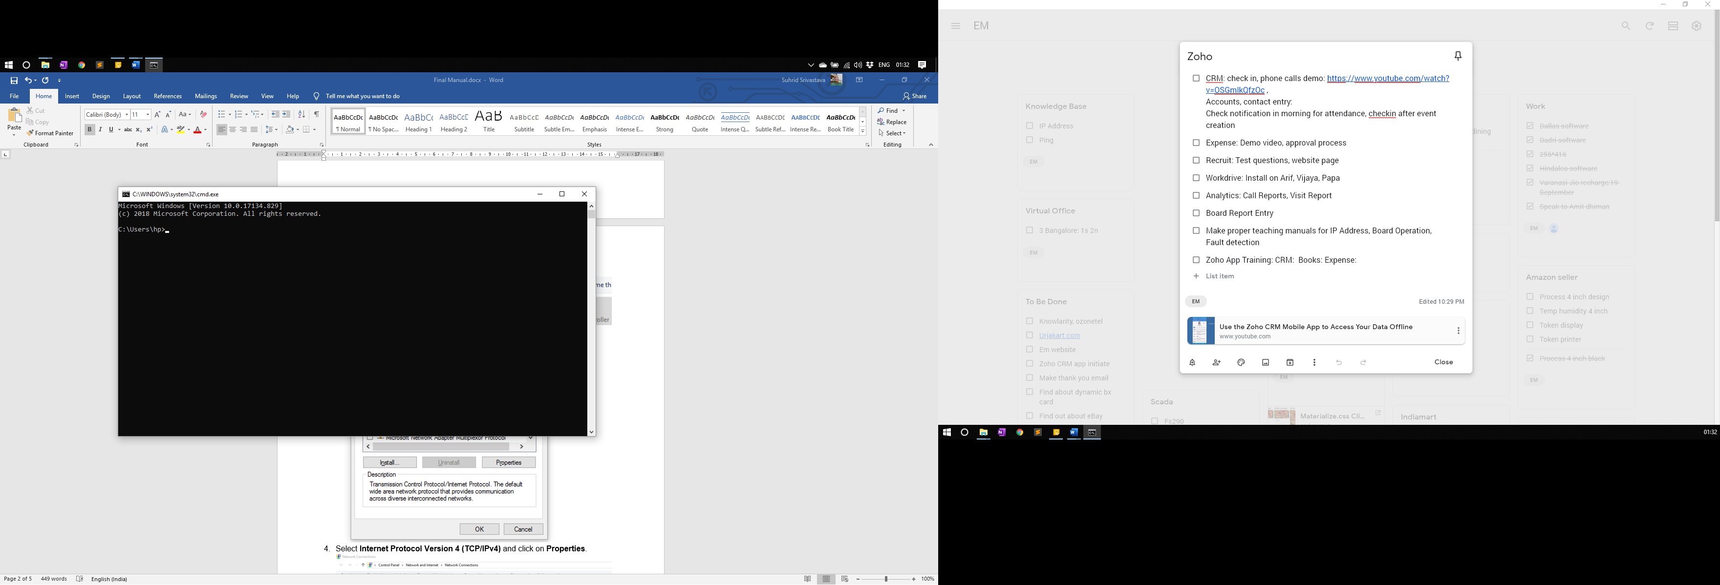

**IP ADDRESS**

An Internet Protocol address is a numerical label assigned to each device connected to a computer network that uses the Internet Protocol for communication.

Every device that communicates on LAN or Internet network has an IP Address. It is just like your home or office address. Just like when sending letter to a person an address is required, the IP Address is required to send data to the device.

There are 3 main IP parameters that must be known to begin work:

1. IP Address
2. Subnet Mask
3. Default Gateway

**Find current IP parameters of PC: Ipconfig command**

Ipconfig command is used to find the IP configuration of the computer.

Step 1: Open Command Prompt

Step 2: ipconfig->Enter

Screenshot

Check the Ethernet adaper details for Wired LAN configuration.

**Setting IP Parameters of PC**

1. Click **Start Menu** > **Control Panel** > **Network and Sharing Center** (For Windows 8 and higher, search for and open Control Panel and select Network and Internet).

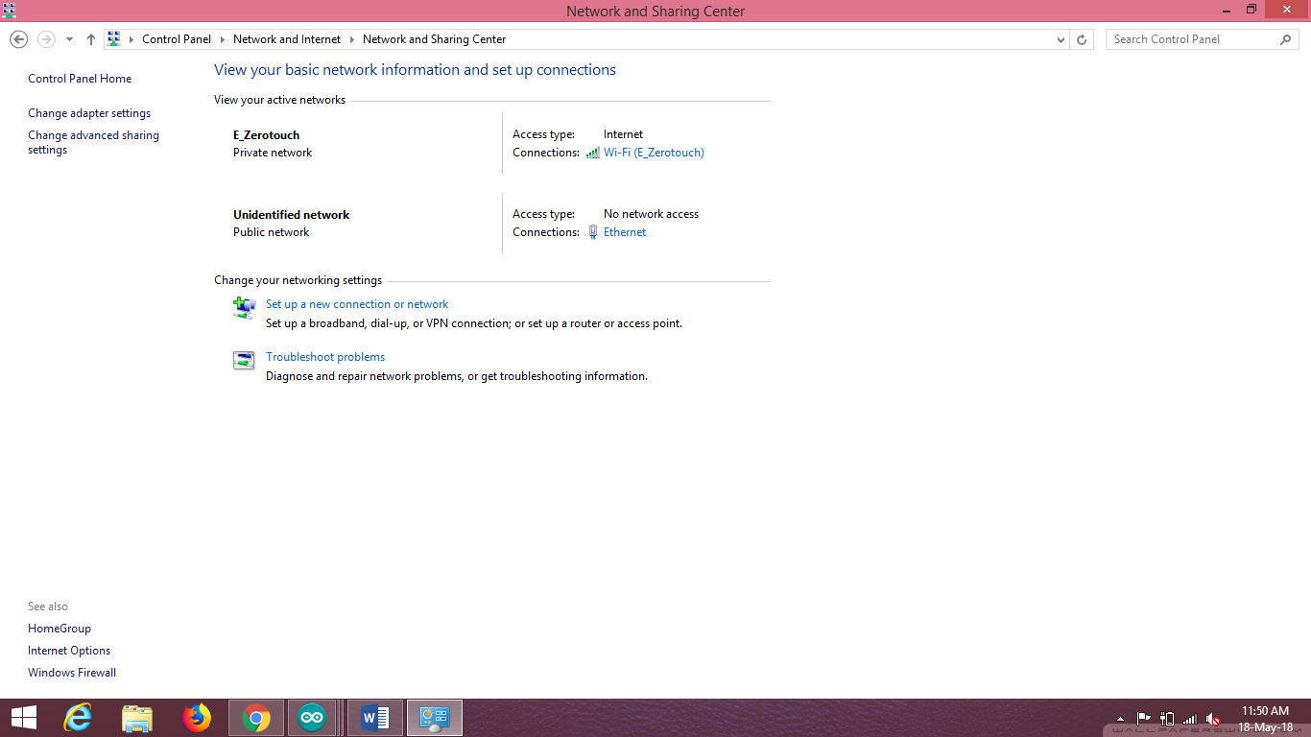

1. Click **Change adapter settings.**
2. Right click on **Local Area Connection** and click on **Properties.**

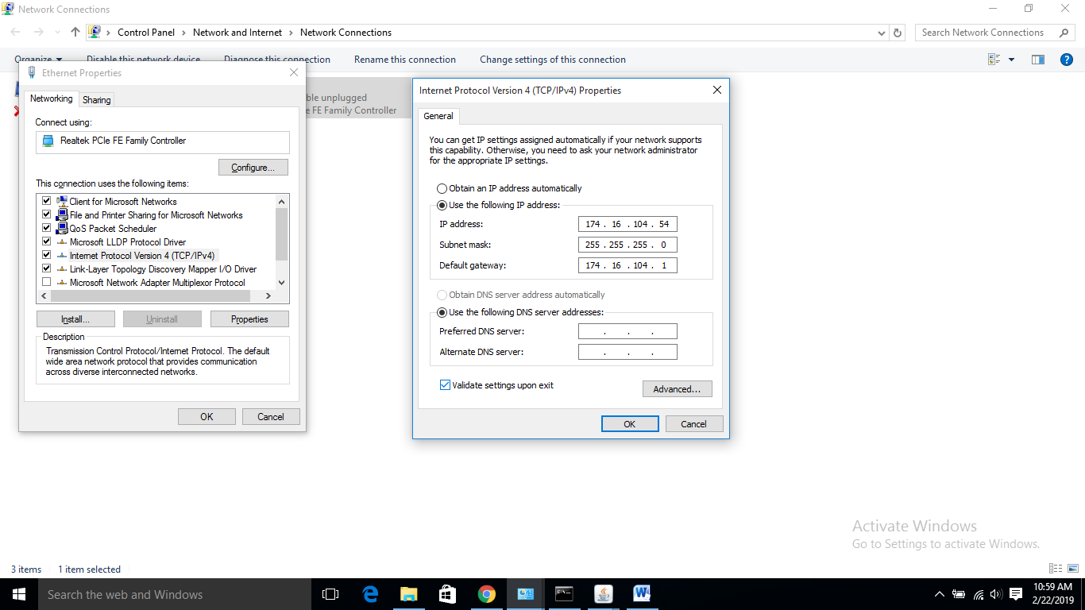

1. Select **Internet Protocol Version 4 (TCP/IPv4)** and click on **Properties**.



1. To use network assigned IP Parameters (for example: parameters of NTPC network) select “**Obtain an IP Address automatically**”
2. To use user defined IP parameters, select “**Use the following IP Address**” and enter the correct parameters.

**Ping Test**

Ping test is used to check whether a device is correctly connected to the network. If ping is successful, that means that all connections are ok, and there is no problem in connection wire or network switches.

However, ping test can sometimes show false positive results if two devices on the network have the same IP Address. You can think of a situation where two houses have the same address, the postman will be confused and may deliver to the wrong house and still have made a complete delivery.

You can ping any computer/ device on the network to check whether it is working or not.

To perform ping test:

1. Open Command Prompt

2. ping <IP Address to be checked> -t

Example ping 192.168.0.123 -t

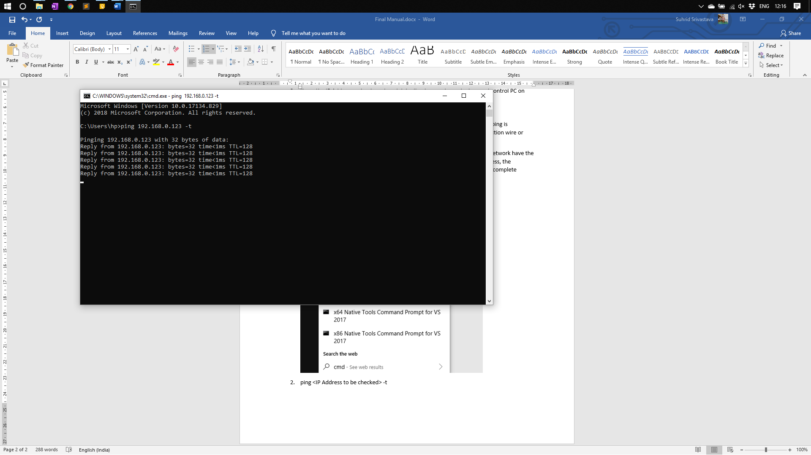

This reply means ping is Ok. If you get any other reply. Ping is not ok.

**Devices on same Network should have same configuration for ping**

* 1. IP Address: <same>.<same>.<same>.<**different**>
  2. Subnet Mask: <same>.<same>.<same>.<same>
  3. Gateway: <same>.<same>.<same>.<same>.

Example:

|  |  |  |
| --- | --- | --- |
|  | **Display Board** | **Control PC** |
| **IP Address** | 10.0.55.215 | 10.0.55.123 |
| **Subnet Mask** | 255.255.255.0 | 255.255.255.0 |
| **Default Gateway** | 10.0.55.1 | 10.0.55.1 |